Vision 2040
1770 – 2021

251 Years Strong

  - Remembering
Rejoicing
Flourishing
Committing

ROCK Rock Presbyterian Church (ECO) 122 Rock Church Road NW
Greenwood SC 29649 864-538-4932
www.rpcgwd.org

PRESBYTERIAN CHURCH , ECO

"Remembering, Rejoicing, Flourishing, Committing"
The 2021 Stewardship and New Building Campaign of Rock Presbyterian Church (ECO)
I think it is fair to Say that 2020 wasn't exactly the year we were expecting it to be. And it certainly wasn't the year we were hoping it would be. Yet, while so much was lost, set aside, or postponed, our God was faithful to walk with us and to bring us safely out of the "valley," as the psalmist may have referred to these past few difficult months. So it is with a spirit of gratitude for God's abundant faithfulness, and with great expectation for the mission and ministry that he is calling us to, that we face these final months of 2020, and the years beyond, with a sense of steadfastness, and even more so, great purpose.
So, with our 250th Anniversary motto before us, we "remember the past, rejoice in the present, and now look to take our
next flourishing step," by continuing ministry and mission, while also adding much needed space to our church facilities for the purpose of doing even more ministry and mission together, all in the name of Jesus Christ and all to the glory of God.
Granted, this will be no small thing. Yet the call to discipleship has never been a small thing. What is being proposed here is quite the undertaking, and a high commitment to this is needed from each covenant partner. The presentation( see presentation above) made Sunday, November 8 (still available on our Facebook and RPC Homepage) will have shown both the need for, and the plan for the addition of new ministry space to meet both the present and current needs of our congregation. As we have been the recipient of so much that those before us sacrificed for, now is the time for us to prepare this place for the generations to come.
As such, we are asking you to do two things:
I. Make a pledge to the Operating Budget for 2021
2. Make a pledge to the Building Campaign that will be completed over the next three years
An appropriate quote provides the context for us as we prayerfully reflect upon our commitment to this next flourishing step.
"We are not asking for equal giving. We are asking for an equal sacrifice. "
In this mailing we have provided you with a 2021 narrative budget to make clear the goals of our life and work together as we worship, study, and serve together. We have also included drawing and plans for the future build. We invite you to pray over these and join us as we renew our commitment to Jesus Christ on Sunday morning, November 22. We invite you to mail your pledge cards back to the office before that day, so that we can pray over them that Sunday morning. Or, if you plan to be with us that Sunday, you can turn them in that day. Believing God for his plans and purposes for us, we trust him to provide the necessary resources to accomplish it.
God is on the move and preparing us for great, great things. Let us find our place on the journey.
Peace,
Dr. Chris Leonard

“To those whom much is given, much is expected.” Luke 12:48

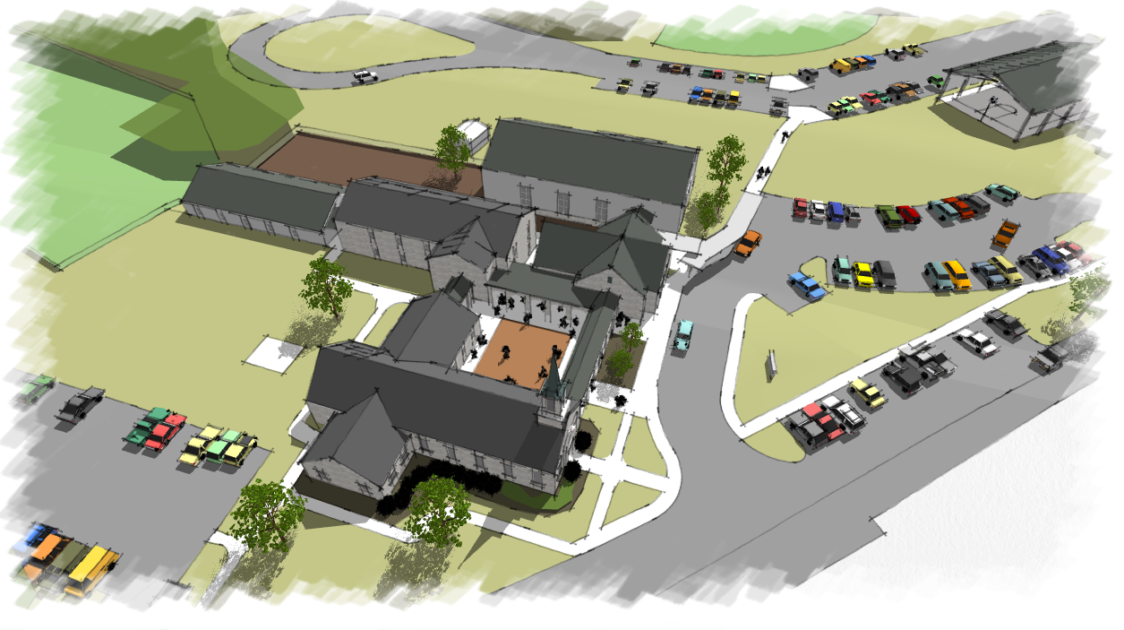

PRELIMINARY BUDGET ESTIMATE | Post Office Box 27234
Rock Presbyterian Church October 16, 2020 | Greenville, SC 29616-7234  864-360-929
GOOD CITY' A R C H I T E C T S
 | Derivati |  |  |  |  |  |  | Component Budget
 |  | PHASE 1: |  |  |  |  | MULTIPURPOSE BUILDING MD ENTRY
 |  | Al | General Construction  Renovations to CE Building  Design and Estimating Contingency |  |  |  |  |  | Lobby and Multipurpose Building, Courtyard and Arcades, Covered Dropoff  Non-structural reconfiguration and finishes of (Al + A2) |  | 175,000  170,000
 |  | A4  A8 | Total Construction Budget  Field Contingency  Professional Compensation  Equipment and Furnishings  Owner^{l}s Testing Allowance |  |  |  |  |  | Al + A2 + A3 5% of A4  8% of A4  Allowance for kitchen equipment, AV systems, and seating  Allowance |  | $ 1,865,000  95,000  150,000  280,000  10,000
Project Budget Estimate
FUTURE PHASES
Parking Expansion  New Children's Building | $ 300,000  570,000
Sanctuary Building Renovations | 330,000
Outdoor Recreation Shelter and Kitchen | 350,000
Outdoor Amphitheatre 190,000
TERMS
General Construction and Renovations include building, building systems and components, and includes general conditions, insurances, permits, and Contractor fees.
Design and Estimating Contingency is a reserve for costs not identified, defined, or fully understood due to the preliminary status of the design and design documents.
Professional Compensation includes normal architectural and engineering design and construction phase services
Field Contingency is a reserve for sub-surface or concealed conditions, directives by Code officials, design omissions, etc.
Allowance is an amount set aside, based on experience with similar projects, in the absence of scope definition.
Owner's Testing includes soil and materials testing required by law to be paid for directly by the building owner.

Big News for 2020!
One time offer!
- The CARES Act encourages charitable giving to RPC (ECO) in 2020
' Itemize to deduct qualified cash charitable contributions, up to 100% of your Adjusted Gross Income (AGI)
- Corporations may deduct up to 25% of taxable income
' Those taking the standard deduction can deduct up to
$300/person or $600/couple
- Please contact your personal tax advisor to see how the CARES Act applies to your contribution to RPC (ECO) in
2020

